**Enhancement to how Shopaware retrieves data**

Because the OpenFDA WebApi does not allow the retrieved data to be sorted we are sorting the data, newest first. This is done so the most relevant data can be presented first. Because we have to sort the data post request we are specifying a date range request, and this is done as trial and error, where each trial is a request to the OpenFDA WebApi. This uses up the number of request per minute/day and reduces performance.

An alternate method would be to make a request to the OpenFDA WebApi and do a count on the date field that the date range filter would be using (figure 1). We would then loop through the data to find the latest date with data. Then we then make the request where the start date of the range is prior he the latest date found. This will mean there are 2 request per endpoint for summary and detail data, were currently we could have 6 request each for summary and detail data on events.

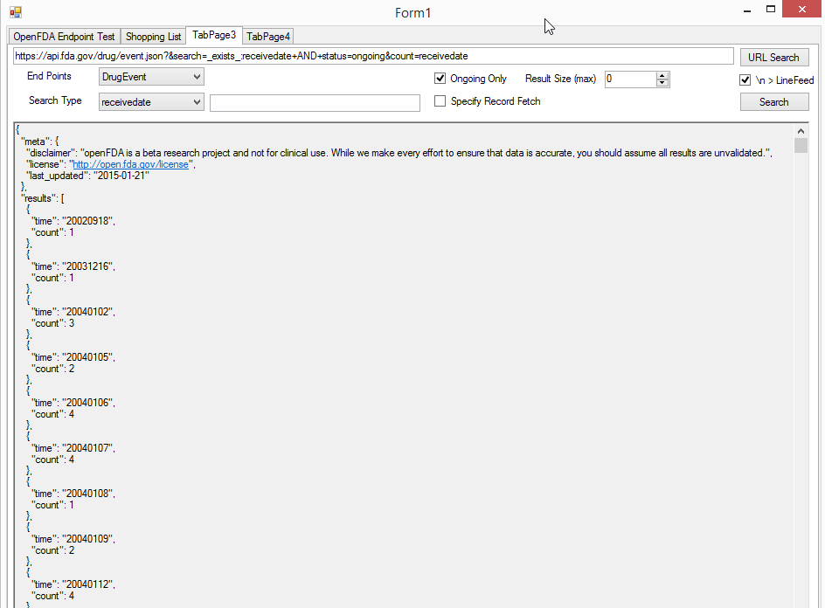

(figure 1)